Important American Speeches and Documents Workbook

Primary Source 1: I Will Fight No More
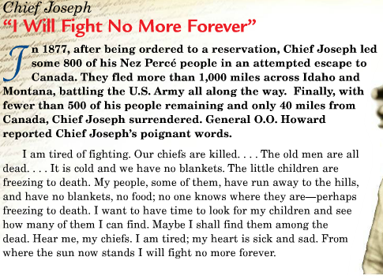
- What is Chief Joseph’s main point?
- What time in history do you think he is talking about?

Primary Source 2: Gospel of Wealth
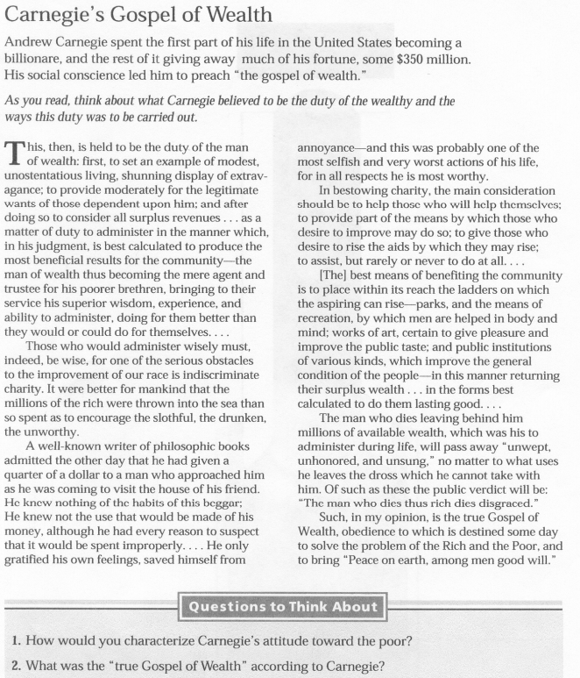

Primary Source 3: William Jennings Bryan’s Cross of Gold

I would be presumptuous, indeed, to present myself against the distinguished gentlemen to whom you have listened if this were but a measuring of ability; but this is not a contest among persons. The humblest citizen in all the land when clad in armor of a righteous cause is stronger than all the whole hosts of error that they can bring. I come to speak to you in defense of a cause as holy as the cause of liberty—the cause of humanity. . . . Here is the line of battle.
We care not upon which issue they force the fight. We are prepared to meet them on either issue or on both. If they tell us that the gold standard is the standard of civilization, we reply to them that this, the most enlightened of all nations of the earth, has never declared for a gold standard, and both the parties this year are declaring against it. If the gold standard is the standard of civilization, why, my friends, should we not have it? So if they come to meet us on that, we can present the history of our nation. More than that, we can tell them this, that they will search the pages of history in vain to find a single instance in which the common people of any land ever declared themselves in favor of a gold standard. They can find where the holders of fixed investments have.
Mr. Carlisle said in 1878 that this was a struggle between the idle holders of idle capital and the struggling masses who produce the wealth and pay the taxes of the country; and my friends, it is simply a question that we shall decide upon which side shall the Democratic Party fight. Upon the side of the idle holders of idle capital, or upon the side of the struggling masses? That is the question that the party must answer first; and then it must be answered by each individual hereafter. The sympathies of the Democratic Party, as described by the platform, are on the side of the struggling masses, who have ever been the foundation of the Democratic Party. There are two ideas of government. There are those who believe that if you just legislate to make the well-to-do prosperous that their prosperity will leak through on those below. The Democratic idea has been that if you legislate to make the masses prosperous their prosperity will find its way up and through every class that rests upon it.
You come to us and tell us that the great cities are in favor of the gold standard. I tell you that the great cities rest upon these broad and fertile prairies. Burn down your cities and leave our farms, and your cities will spring up again as if by magic. But destroy our farms and the grass will grow in the streets of every city in this country. . . . If they dare to come out and in the open defend the gold standard as a good thing, we shall fight them to the uttermost, having behind us the producing masses of the nation and the world. Having behind us the commercial interests and the laboring interests and all the toiling masses, we shall answer their demands for a gold standard by saying to them, you shall not press down upon the brow of labor this crown of thorns. You shall not crucify mankind upon a cross of gold.

1. In his "Cross of Gold" speech, how does Bryan (a Populist-Democrat) depict the Democratic party?
2. How does Bryan characterize cities? How does he characterize farming?
3. How does Bryan depict the gold and the gold standard? How does he depict silver?

Primary Source 4: Wilson’s Fourteen Points

1. All treaties between countries must be made public with no secret agreements for all nations to observe.
2. Freedom of navigation upon the seas, outside territorial waters, during both peace and war, except as those seas may be closed in whole or in part by international action for the enforcement of international agreements.
3. The removal of economic barriers between countries making trade unfair among all the nations consenting to the peace and associating themselves for the maintenance of peace.
4. The reduction of arms worldwide to the lowest point consistent with maintaining domestic (home) safety.
5. An open-minded adjustment of all colonial claims, based upon the principle that in determining all such questions of rule the interests of the populations involved must have equal say with the claims of the government who is involved.
6. The evacuation of Central Power armed forces of all Russian territory.
7. The evacuation of Central Power armed forces from Belgium.
8. All French territory should be freed and the invaded portions restored to France, including lands lost by France (Alsace-Lorraine territory) during the Franco-Prussian War in 1871 (Germany was formally known as Prussia).
9. A readjustment of the borders of Italy should be effected along clearly recognizable lines of Italian nationality.
10. The peoples of Austria-Hungary should be given the freest opportunity to autonomous (self-chosen) government.
11. Romania, Serbia, and Montenegro should be evacuated by all Central Power armed forces; occupied territories restored; Serbia given free and permanent access to the sea.
12. The peoples of the Ottoman Empire should be given a voice in determining their own self-government.
13. An independent Polish nation should be created which should include the territories inhabited by indisputably Polish populations, including free access to the sea.
14. A League of Nations formed so that representatives of all participating nations can peacefully settle disputes without resorting to armed conflict, and that the League of Nations will help protect the freedom of participating nations who are threatened by others.

1. Why does Wilson think that the Fourteen Points re the “only possible program” for the world’s peace?
2. Which of the fourteen points introduced the idea of a League of Nations?

Primary Source 5: President Roosevelt’s Four Freedom’s Speech

I address you, the members of this new Congress, at a moment unprecedented in the history of the union. I use the word “unprecedented” because at no previous time has American security been as seriously threatened from without as it is today…
In the future days, which we seek to make secure, we look forward to a world founded upon four essential human freedoms.
The first is freedom of speech and expression -- everywhere in the world.
The second is freedom of every person to worship God in his own way -- everywhere in the world.
The third is freedom from want, which, translated into world terms, means economic understandings which will secure to every nation a healthy peacetime life for its inhabitants -- everywhere in the world.
The fourth is freedom from fear, which, translated into world terms, means a world-wide reduction of armaments to such a point and in such a thorough fashion that no nation will be in a position to commit an act of physical aggression against any neighbor -- anywhere in the world.
That is no vision of a distant millennium. It is a definite basis for a kind of world attainable in our own time and generation. That kind of world is the very antithesis of the so-called “new order” of tyranny which the dictators seek to create with the crash of a bomb.
To that new order we oppose the greater conception -- the moral order. A good society is able to face schemes of world domination and foreign revolutions alike without fear.
Since the beginning of our American history we have been engaged in change, in a perpetual, peaceful revolution, a revolution which goes on steadily, quietly, adjusting itself to changing conditions without the concentration camp or the quicklime in the ditch. The world order which we seek is the cooperation of free countries, working together in a friendly, civilized society.
This nation has placed its destiny in the hands and heads and hearts of its millions of free men and women, and its faith in freedom under the guidance of God. Freedom means the supremacy of human rights everywhere. Our support goes to those who struggle to gain those rights and keep them. Our strength is our unity of purpose.
To that high concept there can be no end save victory.
1. What are the Four Freedoms?
2. How do you think an Isolationist would respond to Roosevelt’s Speech?

Primary Source 6: Roosevelt Inaugural Address
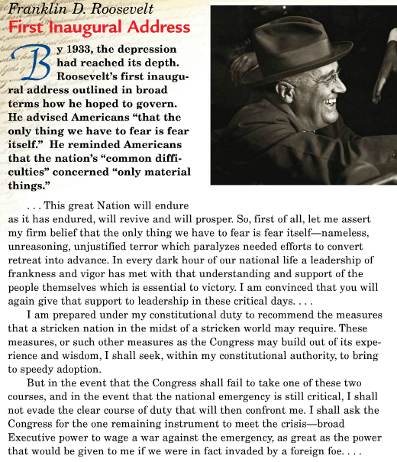

- “The only thing we have to fear is fear itself” is one of the most famous lines spoken by an American president. Why is this line so memorable? What does it suggest about Roosevelt’s vision in 1933?

- How do you think Americans listening to this speech responded to it?

Primary Source 7: FDR’s “Day of Infamy” Speech

Yesterday, December 7, 1941 - a date which will live in infamy - the United States of America was suddenly and deliberately attacked by naval and air forces of the Empire of Japan. The United States was at peace with that nation and, at the solicitation of Japan, was still in conversation with its Government and its Emperor looking toward the maintenance of peace in the Pacific.
Indeed, one hour after Japanese air squadrons had commenced bombing in Oahu, the Japanese Ambassador to the United States and his colleague delivered to the Secretary of State a formal reply to a recent American message. While this reply stated that it seemed useless to continue the existing diplomatic negotiations, it contained no threat or hint of war or armed attack.
It will be recorded that the distance of Hawaii from Japan makes it obvious that the attack was deliberately planned many days or even weeks ago. During the intervening time the Japanese Government has deliberately sought to deceive the United States by false statements and expressions of hope for continued peace.

1. As an American Citizen, what would your reaction be to this speech?
2. Why did the President address Congress directly and not the American people? Was there an exact reason behind it?

Primary Source 7: JFK Inaugural Address

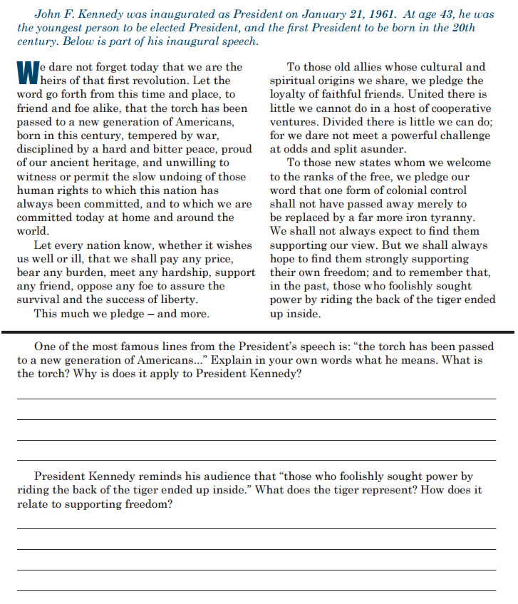

Primary Source 8: MLK’s “I Have a Dream” Speech

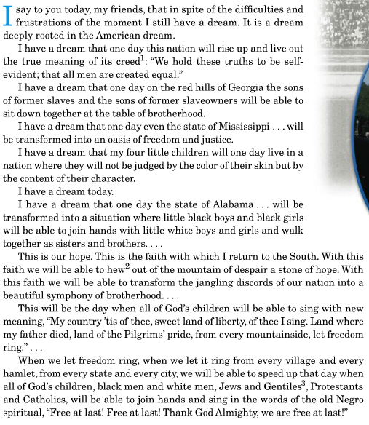
1. What is the “American Dream” to which King refers?
2. How well does King think the nation has lived up to its promises?

Primary Source 9: Reagan’s “Tear Down This Wall” Speech
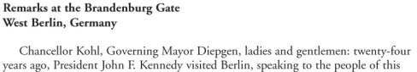
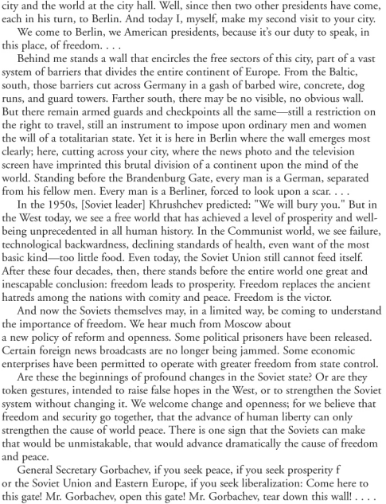
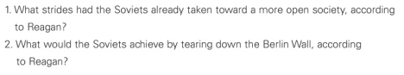

Primary Source 10: PATRIOT ACT discussions

